 **6 Feb 2015** **The Weekly Bulletin of Rotary Club of Kathmandu Mid-Town** **bc-30/2.015**

|  |
| --- |
|  |

District: 3292 Web:www.rotarymidtown.org.np Club Id: 26776

**FEBRUARY IS WORLD UNDERSTANDING MONTH**

World Understanding Month is dedicated for

Rotary’s continued quest for goodwill, peace and understanding

among people of the world.

Club’s Weekly Meeting # 1264 on Friday, 30 January:

Extracts of the Meeting Minutes are given below:

“1. Pres Kul Chandra called meeting #1264 to order.

“6. Pres Kul welcomed our guest speaker Mr Basudev Dahal who is an expert on international finance and development

Rtn Bhairaja gave the formal introduction that was a précis from a CV that was some seven pages long and included a

stint at Harvard Univ., USA. The speaker gave a sweeping view of his extensive experience in development and said

that Nepal has excellent potential in hydropower, organic exports, agriculture, and tourism. He praised the resourceful-

ness of the Nepali people but said that donors also have a role to play in sharing their experience. Rtn Amar gave the

 vote of thanks.

“7. Pres Kul exchanged flags with Edward O'Brien and May Yoneyama Gwinn of the Rotary Club

of Washington D.C. They mentioned how their Club was working with PHASE Nepal. Anyone

who is interested can see their web page at: http://phasenepal.org/

“8.Information sharing:

> Pres Kul reminded everyone to sign up for the Rotary Peace Conference which will take place

Feb 6-9 2015 in Lumbini. Please see for more information at

www.facebook.com/pages/Rotary-Peace-Conference-D3292/1896084613864934

> The Gopal/Kamala Rajbandari Award will be awarded on Feb 6 at the Presidential Palace

> The RI District 3292 Annual District Conference will take place at the end of Feb 2015.

> Pres Kul recommended everyone to please contribute to the TRF- $100 per year.

> Pres Kul informed that PP Giri was not feeling well and that he might appreciate a 'get well

soon' message from concerned Mid-Towners. PP Giri can be reached at

[giridher.manandhar@gmail.com](mailto:giridher.manandhar@gmail.com) or by phone at 9751012433, or 9851021292.

> Mid-Town's fundraising dinner will take place on 28 March – Please participate and donate generously. More

information will be forthcoming shortly.

> PP Mani informed that the 'Gift of Sight' was taking place starting today in Hetauda. The RC Singapore Garden City

and other Singapore clubs had joined to give $6000 for the screen and medical interventions.

“9. Statistics of the meeting: Members present: 23”.

# Weekly Meetings and Programs :

|  |  |  |
| --- | --- | --- |
| Date | Program/ Speaker | Topic of Presentation |
| 6 February | Chris Koch | . |
|  |  |  |
|  |  |  |

Friday, 6 February:

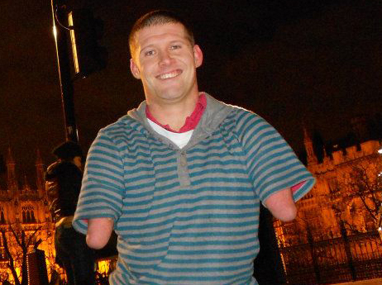

Mr. Chris Koch, who was born a quadruple amputee and benefited from the

Canadian Military’s War Amputee Program called *‘Champs’* almost from birth,

is in the town. He has created an adventure-filled life for himself and is now, at 35,

a motivational speaker. Chris will be with us on Friday morning as the guest

speaker. Chris has a website called ’If I can’ (<http://www.ifican.ca/).>

Being born without limbs, Koch has accomplished more than most able-bodied

folks do in a lifetime.

Growing up, he learned to golf, ski, snowboard and play the piano, along with

putting in countless hours as a volunteer. He has travelled far and wide on his

skateboard. He climbed all 802 steps of Calgary Tower in less than a half-hour.

‘[If you want to make peace with your enemy, you have to work with your enemy. Then he becomes your partner.](http://www.brainyquote.com/quotes/quotes/n/nelsonmand133378.html)’

*- Nelson Mandela*

**Rotary South Asia Conference on Peace: 7-9 Feb 2015**

**At Lumbini Garden**

‘[Peace and justice are two sides of the same coin.](http://www.brainyquote.com/quotes/quotes/d/dwightdei121901.html)’

- [**Dwight D. Eisenhower**](http://www.brainyquote.com/quotes/authors/d/dwight_d_eisenhower.html)

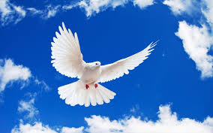

*Peace begins with a smile*

*Mother Teresa*

[Peace is a daily, a weekly, a monthly process, gradually changing opinions, slowly eroding old barriers, quietly building new structures.](http://www.brainyquote.com/quotes/quotes/j/johnfkenn135037.html)

John F. Kennedy

**Peace is a journey of a thousand miles and it must be taken one step at a time.**

**Lyndon B. Johnson**

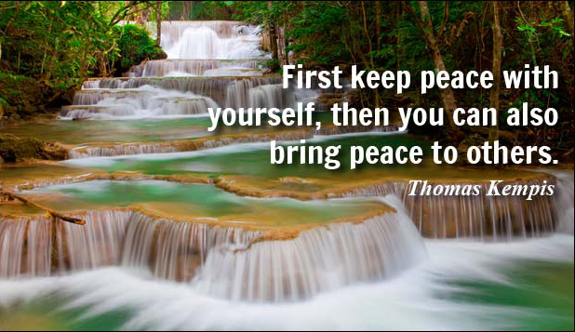

**-** [**Peace cannot be achieved through violence, it can only be attained through understanding.**](http://www.brainyquote.com/quotes/quotes/r/ralphwaldo107033.html)

***-*** [***Nobody can bring you peace but yourself.***](http://www.brainyquote.com/quotes/quotes/r/ralphwaldo140608.html)

**~~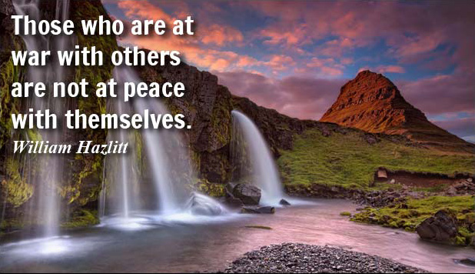~~**

**RI President-elect K.R. Ravindran ‘Ravi’**

announces Presidential theme for 2015-16



Incoming district governors enthusiastically greeted the presidential theme for 2015-16, Be a Gift to the World, during a dinner 18 January at the International Assembly, Rotary’s annual training event for future district leaders. RI President-elect K.R. “Ravi” Ravindran is asking Rotary members to use their talents, expertise, and leadership in the coming year to transform the lives of others.

**SUMMARY OF ROTARY ACTIVITIES PROMOTING WORLDWIDE PEACE**

*"The way to war is a well-paved highway and the way to peace is still a wilderness."* Paul P. Harris From a recorded interview in Tuskegee, Alabama, USA in 1945.

Rotary, by reaching within to embrace humanity is joining to help move man-kind from a culture of war to a culture of Peace!

Sakuji Tanaka, RI President 2012-13 chose the theme of Peace Through Service is consistent with the Mission of the Foundation...

To enable Rotarians to advance World understanding, good will and peace through the improvement of health, the support of education, and the alleviation of poverty…….More in ‘Annex’

*Source: Internet News*

Travel / Tourism



“I would like to spend my whole life traveling, if I could borrow another life to spend at home” William Hazlitt

**A THOUGHT FOR TODAY:**

**[Peace is not an absence of war,](http://www.brainyquote.com/quotes/quotes/b/baruchspin101666.html" \o "view quote)**

**[it is a virtue, a state of mind,](http://www.brainyquote.com/quotes/quotes/b/baruchspin101666.html" \o "view quote)**

**[a disposition for benevolence, confidence, justice.](http://www.brainyquote.com/quotes/quotes/b/baruchspin101666.html" \o "view quote)**[**Baruch Spinoza**](http://www.brainyquote.com/quotes/authors/b/baruch_spinoza.html)

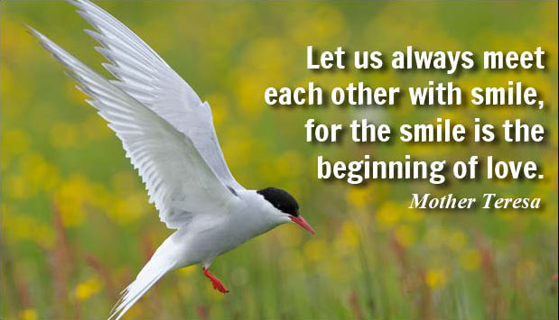

On Lighter Side:

**We are here on earth to do good unto others.**

**What the others are here for, I have no idea !**

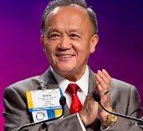

I've heard stories of how our service changes the lives of others, and how it changes us as

Rotarians. When I hear these stories, I can't help but wonder: How many other lives could

we change for the better by bringing more people into Rotary? And how many more people

could we bring into Rotary simply by sharing our own Rotary stories?

**RI President GARY C.K. HUANG**

## 6 February 2015 The Weekly Bulletin of Rotary Club of Kathmandu Mid-Town bc-30/2.015

*******************************

Annex

**SUMMARY OF ROTARY ACTIVITIES PROMOTING WORLDWIDE PEACE**

**Peace is in our Hands!**

***‘Service Above Self’ Leads to Peace***

**Keeping Free of Political And Religious Agendas Yet honoring the Dignity of Man for Order and Prayer makes….**

**ROTARY - PEACE IN ACTION**

***"The Rotary way works! But Rotary has no patent on it, for it is but the Golden Rule in action. Any person, any nation, can apply it by displacing negative hatred and fear with goodwill based upon understanding. Peace among nations is not impossible of attainment; they can find peace if they will."* Paul P. Harris, January 1946**

***"The way to war is a well-paved highway and the way to peace is still a wilderness."* Paul P. Harris From a recorded interview in Tuskegee, Alabama, USA in 1945.**

**Rotary, by reaching within to embrace humanity is joining to help move man-kind from a culture of war to a culture of Peace!**

**Sakuji Tanaka, RI President 2012-13 chose the theme of *Peace Through Service is consistent with the Mission of the Foundation...***

***To enable Rotarians to advance World understanding, good will and peace through the improvement of health, the support of education, and the alleviation of poverty.***

**Rotary’s Peace History**

**1914** The Rotary Club of Minneapolis, MN sends a proposal to the International Association of Rotary Clubs suggesting that all clubs become peace advocates in their communities.

**1922** At the Rotary convention in Los Angeles, delegates resolve to establish international peace as part of the Object of Rotary and to change the name of the organization to Rotary International.

**1940** At the RI Convention in Havana, delegates resolve that where freedom, justice, truth and sanctity of the pledged word and respect for human rights do not exist, Rotary cannot live.

**1942** London Rotarians convene a world peace conference attended by representatives of 21 governments. The leadership group that emerges from this event evolves into UNESCO.

**1945** At the UN Charter Conference in San Francisco more than 40 Rotarians participate as delegates or consultants. US Secretary of State Edward R. Stettinius declares the invitation is a “simple recognition of the practical part Rotary members have played and will continue to play in the development of understanding among nations.”

**1981** At the RI Convention in São Paulo, Brazil, the first Rotary Award for World Understanding and Peace is given to Noburu Iwamura of Japan for his work with the sick and the poor in Nepal and throughout Asia.

**1988** The Rotary Foundation holds its first Peace Forum, laying the groundwork for the Rotary Centers for International Studies in Peace and Conflict Resolution.

**1994** The Rotary club of Skoyen, Norway, establishes a peace project through which Israeli and Palestinian students attend an all-expense-paid summer study program in Oslo.

**2007** Rotary hosts its first Rotary World Peace Symposium, a preconvention opportunity for current and former Rotary World Peace Fellows and Rotarians to connect and exchange ideas. It draws nearly 400 participants.

**2009** Archbishop Desmond Tutu speaks at the second Rotary World Peace Symposium. The Rotary Centers program now has more than 400 alumni.

**2012** Third Peace Symposium in Bangkok, Thailand, Former Sudanese soldier, Emmanuel Jal pumps up the volume and opens his keynote speech not by talking about peace but rather by singing about it.

**Rotary Centers for International Studies in Peace and Conflict Resolution**

Rotary Peace Fellows are leaders promoting national and international cooperation, peace, and the successful resolution of conflict throughout their lives, in their careers and through service activities. Fellows earn a master degree at the seven universities in international relations, public administration, sustainable development, peace studies, conflict resolution, or a related field, or a professional development certificate in peace and conflict resolution.

**Small sample of Peace-Promoting Web Sites:**

***we.net PeaceOneDay.org CultureofPeace.org thePeaceAlliance.org Theshiftnetwork.com 10millionclicksforpeace.org InternationalCitiesofPeace.org***

***WorldWidePeaceBellFoundation.org***